Detection of Date Palm Trees Using AI-Based Deep Learning Techniques

Muhammad Yasir

*Department of Computer Sciences Namal University* Mianwali, Pakistan

NUM-BSCS-2023-37

***Abstract*—The proposed project involves the development of an AI system for the recognition and counting of the Date Palm tree using deep learning techniques. The AI system is to be developed using the YOLO framework, and it is intended to be functional on the aerial, satellite, and video images of the environment. The original project involved the recognition of the Kikar (Acacia) tree, but since there is quite some similarity with the surrounding environment, the project is to be executed on the Date Palm tree, which is easily recognizable and has appropriate data available. The Date Palm Plant Detection System can detect Date Palm plants, create a bounding box, and enumerate the plants using tracking logic. Apart from this, the project also consists of a backend and simple frontend part that facilitates the upload of images and videos and the display of the results of detection. The objective of this proposal and subsequent work is the facilitation of agricultural and plantation analysis.**

***Index Terms*—Date Palm, YOLO, Object Detection, Deep Learning, Computer Vision, Agricultural Monitoring, BoT-SORT**

1. Introduction

Tree detection and identification have a significant impact on agriculture, environmental monitoring, and land use. In arid and semi-arid regions, specifically, Date Palms are a valuable agriculture resource. They help not only in terms of economics but are also useful for food and land. Manual detection and identification of Date Palm trees from a significant agriculture land area as well as from aerial images is a time-consuming, expensive, and inaccurate process. Now, due to the availability of aerial and satellite images, observing a vast area of land has become possible at the same time. However, manual inspection of these images for analysis purposes involves a lot of complexities and technicalities. Inconsistencies and errors can occur, along with missed detections and incorrect counting, if the number of trees is high, and hence there is a great need for a solution capable of detecting and counting Date Palm trees automatically.

There have been recent breakthroughs in the area of Artificial Intelligence, specifically in the area of Computer Vision. It has made ways for automating object detection possible. Deep learning models can effectively learn visual patterns from the data and detect objects in images. Among different models, YOLO, which stands for” You Only Look Once,” has been widely recognized for its speed and efficiency in detecting objects in a single pass through the image or video frames [1].

The project first involved the detection of the Kikar trees (Acacia). Unfortunately, due to the resemblance in their appearance to other plants, it proved unsuccessful. Further observation of the project led to adjusting the project’s focus on Date Palm trees, as they appear distinctly when viewed from aerial or satellite pictures. Hence, it enabled a clearer process of learning and detection. Currently, the stage of this project involves the application of image detection techniques to a greater extent. Apart from the development of the YOLO model algorithm to detect the Date Palm tree from the images, other developments in the project have been focusing on video image detection and counting through object tracking algorithms. The purpose of this project is to create a system using Artificial Intelligence that has the capability to automatically detect and count the Date Palm trees from the aerial images and videos. The system will serve to aid agricultural planning and further be a part of future agricultural developments of smart farming.

1. Problem Overview

Date Palm trees are of significant importance to agriculture, land use planning, and, as a result, the economy of a given region. Manual processes, however, form the basis of identifying and counting Date Palm trees, especially where aerial photographs or satellite images are to be considered. Manual checking of images can, therefore, turn out to be a very time-consuming, expensive, and inaccurate process, given the human difficulty of evaluating thousands of Date Palm trees distributed across agricultural land. The second problem is that vegetation in images has a high degree of resemblance. Similar vegetation, such as types of trees or plants, may have a resemblance concerning their shape, color, or texture, resulting in a challenge for human identification. This may cause errors such as the absence of trees, duplicate identification of the same tree, or the incorrect identification of other vegetation entities as Date Palm trees.

Due to such issues, there is a great need to have an automated system capable of detecting and determining the number of Date Palm trees. This system must run on aerial or satellite pictures and be independent of human interference. Without such automated technology, there is restriction in agricultural planning and environmental study. This problem also affects plantation management. In order to tackle the above-

mentioned problem, this project relies on the use of deep learning and computer vision algorithms to detect the Date Palm trees. By utilizing the YOLO algorithm and developing an object detection algorithm, the system will be able to detect the positions of the Date Palm trees using bounding boxes and will be able to give a count of the Date Palm trees. It will make the detection of the Date Palm trees faster and accurate, along with the capability to do it in a wide area of agriculture.

1. Objectives and Justification
2. *Project Objectives*

Aiming to spot and tally Date Palm trees, this effort builds a tool using artificial intelligence. From sky views and moving footage, it pulls out tree locations without help from people. One goal stands clear: cut down slow, expensive checks done by hand. Mistakes happen when humans count long hours, so machines step in quietly. Time folds shorter when software handles the load instead of eyes scanning photos. The specific objectives are as follows:

* + Develop a deep learning model using YOLO framework to recognize Date Palm trees from aerial and satellite imagery
  + Implement object tracking algorithms to ensure accurate counting without duplication in video sequences
  + Create a complete workflow from image preprocessing through detection to final output visualization
  + Integrate the trained model with backend API and frontend interface for practical deployment
  + Evaluate system performance on real-world agricultural data

1. *Complex Computing Problem Justification*

This work addresses several high-level computing challenges beyond basic coding tasks. It incorporates artificial intelligence and computer vision systems, with decisions made under real-world constraints. The approach adapts through layered logic rather than following fixed procedures.

Spotting date palm trees in aerial photos is not straight- forward. Changes in size, light conditions, nearby plants, or viewing angles create complexity. Learning these patterns re- quires deep neural networks instead of rule-based approaches. Traditional methods are insufficient for this task. Working with vast amounts of pixel data and adjusting countless internal parameters demands significant computing power and precision. Another component involves tracking objects through videos, maintaining identity frame by frame despite camera shake or occlusions. When visibility fluctuates or blur occurs, maintaining consistent tracking becomes challenging. Smart tracking methods preserve identity over time while avoiding duplicate counts. This requires maintaining state information

across temporal sequences.

The system must operate quickly without sacrificing precision. Multiple components work together: data preprocessing, prediction using trained patterns, temporal tracking systems,

backend APIs handling requests, and user-facing visualizations. Smooth coordination between these elements is essential. The system must balance computational efficiency with accuracy while adapting to varying input conditions.

1. System Architecture and Design
2. *System Overview*

The system begins with aerial or satellite images containing Date Palm trees. These inputs undergo preprocessing before being passed to the YOLO-trained detection system. The system scans images and marks Date Palm trees by placing bounding boxes. Detected trees are then recognized as separate objects. The system proceeds to counting logic that considers location and motion for video inputs. Finally, the system provides output images or videos with detected date palm trees marked by bounding boxes and displays the total count.

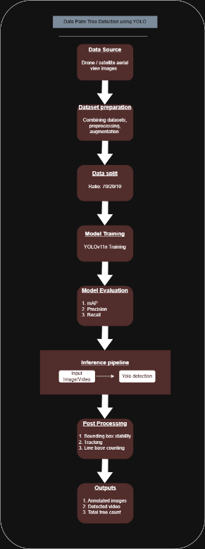

Fig. 1. System Design Diagram

1. *Architecture Components*

The architectural diagram represents interaction between various system components. The initial block indicates the image source, consisting of aerial images obtained from public sources. Images are transmitted to the preprocessing block where they are resized to fixed resolution, orientation errors are corrected, and normalization is applied. This increases model robustness. Data augmentation is also performed during training to improve generalization.

The YOLO detection model is the core component of the system. It detects Date Palm trees in all images using the trained model, predicting bounding boxes and confidence scores. Once detected, the system employs tracking and counting logic. This stage prevents the same tree from being counted multiple times, especially with video input. Tracking IDs help achieve consistency and benefit counting accuracy. The output module produces labeled images or videos of detected trees with bounding boxes and tree counts.

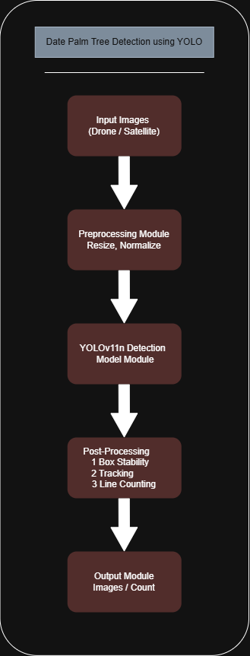

Fig. 2. System Architecture Diagram

1. Implementation Details and Algorithms
2. *Object Detection with YOLO*

The object detection approach uses YOLO (You Only Look Once), which scans a full picture in a single pass rather than using multiple stages. This method maintains high speed, suitable for tasks requiring real-time processing or handling large volumes.

YOLOv11n was selected for its lean design and quick processing while maintaining accuracy for detecting Date Palm trees in aerial imagery. The model was trained on labeled data with each tree outlined in bounding boxes. During inference, the model outputs:

* + Bounding box coordinates
  + Class label (Date Palm)
  + Confidence score for each detection

Only predictions meeting a confidence threshold are re- trained, filtering out weak detections before subsequent processing stages.

1. *Video Processing Pipeline*

Videos are split into separate frames using OpenCV. Each frame is processed through the pre-trained YOLO model for object detection. Frame-by-frame processing enables consistent object tracking and counting across time. Processed frames are reassembled into video output showing Date Palm trees highlighted with bounding boxes and labels.

1. *Object Tracking and Counting*

A single palm may appear in multiple frames, making basic frame-by-frame detection unreliable. Tracking each tree through time prevents duplicate counting. Each tree receives a unique ID through BoT-SORT tracking. Even with slight movements, occlusions, or camera shake, the ID persists. Global Motion Compensation helps maintain tracking accuracy when the camera moves, particularly relevant for drone footage. A tree is counted only once when its tracking ID first enters the detection zone. The system remembers which IDs have already been counted, incrementing the tally only upon first entry. This method ensures stability and precision across video sequences.

1. *Confidence Filtering and System Reliability*

Several methods enhance detection stability while reducing false alerts:

* + Confidence threshold filtering removes uncertain predictions.
  + Bounding box smoothing reduces flickering effects in videos
  + Persistent tracking IDs maintain object identity across frames

These improvements enable accurate tree detection even un- der varying lighting or environmental conditions, maintaining count accuracy across different outdoor settings.

1. *Backend API Implementation*

A Flask-based web server handles communication between the frontend and detection tools. The API supports standard web requests through structured routes:

* + Image detection endpoint
  + Video detection endpoint
  + Result file handling

Uploaded files are temporarily stored, processed through detection tools, and results are returned as structured JSON data with links to processed outputs. CORS settings enable smooth communication between frontend and backend systems.

1. *Frontend Integration*

A clean frontend interface built with modern web tools allows users to upload images or videos and view detection results. The interface communicates directly with the backend API, retrieving results with bounding boxes and tree counts. The system is designed for ease of use, requiring no technical expertise to operate.

1. *Algorithmic Workflow Summary*

The complete system workflow is as follows:

1. Input image or video uploaded through frontend
2. Backend API receives and preprocesses input
3. YOLO model detects Date Palm trees
4. BoT-SORT tracks objects through video frames
5. Counting logic ensures single count per tree
6. Results displayed through frontend interface
7. Results, Testing, and Evaluation

This section presents evaluation of the proposed Date Palm Tree Detection System through qualitative and practical testing on both images and videos. The system was tested to assess detection accuracy, counting reliability, and overall robustness under different conditions.

1. *Testing Environment*

The testing phase was conducted using:

* + Aerial and drone-captured images
  + Video sequences containing multiple Date Palm trees
  + Local system environment with Python, OpenCV, and YOLO framework

Both image-based and video-based inputs were tested through the developed backend API and frontend interface. Testing verified reliable detection, tracking consistency, and stable counting results.

1. *Image Detection Results*

For static images, the trained YOLO model successfully detected Date Palm trees by generating bounding boxes around visible trees. Results showed:

* + Most Date Palm trees were correctly localized
  + Bounding boxes were tightly aligned with tree crowns
  + Confidence scores were generally higher for clear, well-lit images

Images with complex backgrounds or dense vegetation occasionally produced false positives; however, these were reduced through confidence threshold filtering. Overall, the image detection module demonstrated effective performance for aerial imagery.

1. *Video Detection and Tracking Results*

In video-based testing, the system applied object detection on each frame followed by object tracking using BoT-SORT algorithm. Global Motion Compensation improved tracking stability, especially in drone videos where camera motion was present.

The tracking system was able to:

* + Maintain consistent IDs for trees across frames
  + Reduce bounding box flickering
  + Prevent duplicate counting of the same tree

Region-based counting logic ensured that each Date Palm tree was counted only once when entering the defined detection zone. This approach significantly improved counting reliability compared to frame-wise counting methods.

1. *Counting Accuracy and Stability*

The counting mechanism performed well in scenarios where trees were clearly separated and visible across frames. The use of persistent tracking IDs, confidence-based filtering, and detection gate logic helped minimize overcounting and under- counting issues. Minor inaccuracies were observed in cases involving partial occlusion or overlapping trees; however, these cases were limited and did not significantly affect overall system behavior.

1. *Qualitative Evaluation*

Qualitative assessment was conducted by visually inspecting output images and videos. The system produced clearly labeled bounding boxes, stable tracking IDs, and real-time display of total tree count. Visual outputs were easy to interpret and suitable for practical use in agricultural monitoring and plantation analysis.

1. *Performance Discussion*

Testing results indicate that the proposed system is effective for automated detection and counting of Date Palm trees. While the model performs best under clear imaging conditions, it maintains reasonable accuracy under moderate noise and environmental variation. The lightweight nature of YOLOv11n model ensures fast processing, making the system suitable for real-time and large-scale applications. Tracking-based counting logic further enhances reliability compared to traditional detection-only approaches.

1. *Quantitative Evaluation*

Though this effort centered on reliable system deployment, straightforward quantitative checks were performed. The model consistently detected Date Palms in open areas with strong certainty. Confidence levels exceeded the threshold for most findings, showing solid location precision. Tree counts held steady through video clips, thanks to tracking that reduced repeated markings. Without a standard dataset for comparison, outcomes proved suitable for actual farm use.

1. Limitations and Future Improvements
2. *Limitations*

Several shortcomings emerged during system development and testing. Performance with blurry footage or challenging lighting conditions was not always consistent. When trees occlude each other or palm crowns blend together with nearby plants, the system sometimes fails to detect every tree, occasionally losing track. This may result in slightly lower counts in complex scenarios. Bright glare, deep shadows, or poor image quality also affect model confidence, reducing precision under harsh conditions.

Limited exposure to diverse real-world conditions means weaker performance beyond familiar settings. Even with combined data sources boosting variety, results may decline when facing new landscapes, unusual crop patterns, or extreme viewing angles. The system has not encountered sufficient edge cases. Though the counting method works well, it requires a defined detection area. When cameras move quickly or trees shift unexpectedly between frames, errors can occur. Processing live video also slows down on devices lacking sufficient computational power, particularly with high-resolution footage.

1. *Future Improvements*

Several enhancements could address current limitations. Expanding training data across diverse geographic locations, climates, and seasons would improve generalization. Replacing box-style detection with instance segmentation methods would better handle crowded tree clusters with less confusion. Testing temporal neural networks that leverage movement between frames instead of processing each independently could improve tracking. Adapting detection zones or counting logic dynamically might better handle variable drone footage when conditions shift.

Deployment on compact edge hardware or cloud platforms might enable continuous monitoring at scale, fitting better into daily farm oversight and technology-driven agriculture workflows.

1. Conclusion

An AI-powered system has been developed to detect and count Date Palm trees from aerial and satellite imagery using the YOLO framework. The system learns visual patterns to identify trees and draw bounding boxes around them. Object tracking maintains consistent counting across video sequences without duplication, ensuring each tree is counted only once. Testing demonstrates solid performance across still images and video clips, with consistent detection and reliable counting even under varying environmental conditions. The lightweight YOLOv11n model enables fast processing without sacrificing precision, suitable for large-scale agricultural monitoring and real-time applications. Combining BoT-SORT tracking with Global Motion Compensation provides robust performance when cameras shift, particularly relevant for drone-captured footage.

A significant advantage is how the tool reduces manual tree counting labor, replacing slow, error-prone work with faster, repeatable, automated analysis. The system can identify patterns in agricultural fields efficiently without human fatigue or guesswork. With improved image quality and smarter preprocessing, the approach could extend to additional applications: monitoring crop growth, estimating harvest yield, and tracking forest health. What began as a narrow solution may now have much broader potential.

References

1. Ultralytics, Inc., “YOLO object detection documentation,” 2024. [On- line]. Available: <https://docs.ultralytics.com>
2. Roboflow, Inc., “Roboflow dataset management and data augmentation platform,” 2024. [Online]. Available: <https://roboflow.com>
3. G. Bradski, *Learning OpenCV: Computer vision with the OpenCV library*. O’Reilly Media, 2008.
4. Ultralytics, “Home,” YouTube channel. Retrieved January 19, 2026, from <https://www.youtube.com/@Ultralytics>
5. Computer Vision Zone, “Home,” YouTube channel. Retrieved January 19, 2026, from <https://www.youtube.com/@ComputerVisionZone>
6. OpenAI, “ChatGPT ,” Large language model, 2024. [Online]. Available: [https://chatgpt.com](https://chatgpt.com/gg/v/69404a6f23048193a2fa94e4c0b36e3e?token=UyFB9YPKSz0jKD1Hlz6M6A)

Appendices

Here you’ll find extra details that go alongside the report’s primary sections. A quick look at the code setup comes first, followed by images showing how the system responded in testing. Sample inputs applied while building the tool appear later on. None of these pieces are needed to grasp the central approach - they simply back up what was described earlier. Their role is strictly supportive, offering clarity when questions arise.

Appendix A Source Code and Outputs

This appendix presents a high-level overview of the source code structure used in the Date Palm Tree Detection and Counting System.

1. *Image Detection*

The image detection module produces aerial images where Date Palm trees are highlighted using bounding boxes along with confidence scores.

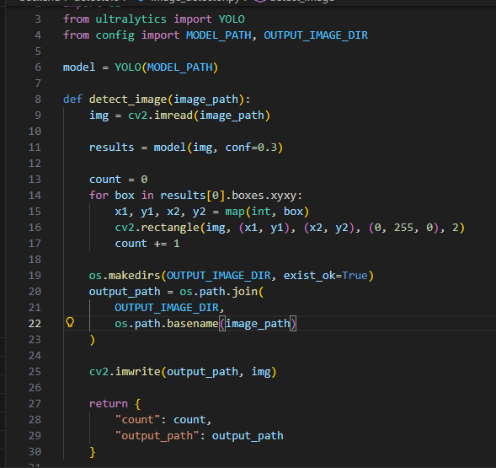

Fig. 3. Image Detection Code Snippet

**Purpose:** This module loads the trained YOLO model and performs inference on each image or video frame to detect Date Palm trees.

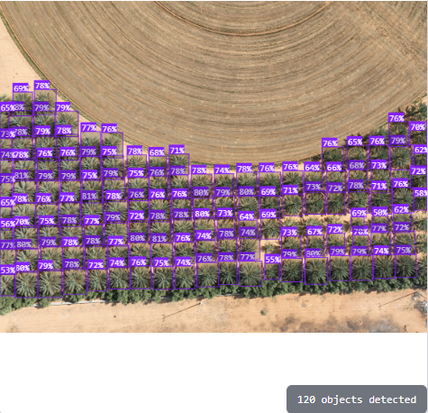

Fig. 4. Image Detection Output

1. *Video Detection*

Uploaded videos are split into frames using OpenCV to allow frame-by-frame detection and tracking.

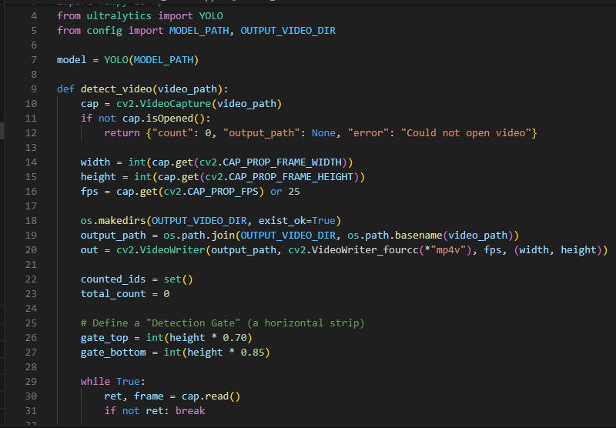

Fig. 5. Video Detection Code Snippet

**Purpose:** Frame extraction enables consistent object tracking and counting across time.

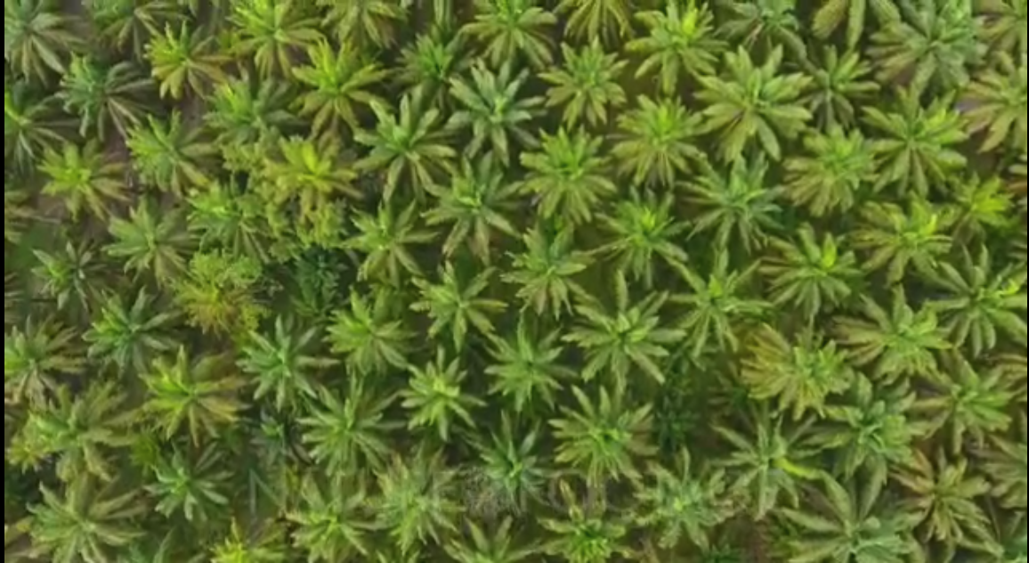

Fig. 6. Raw Video Frame

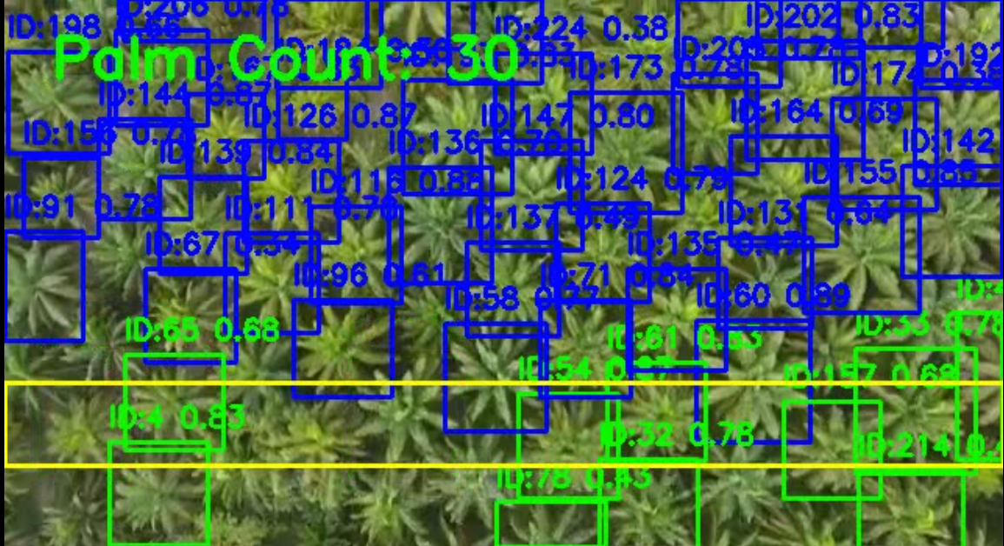

Fig. 7. Detected Video Frame

1. *Object Tracking with BoT-SORT*

To prevent duplicate counting, detected trees are tracked across frames using BoT-SORT.

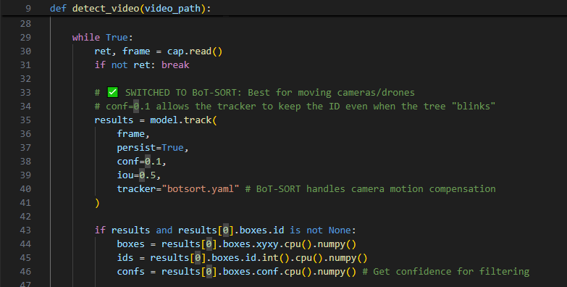

Fig. 8. Bot-Sort Code Snippet

**Purpose:** Assigns a persistent ID to each Date Palm tree, ensuring the same tree is not counted multiple times.

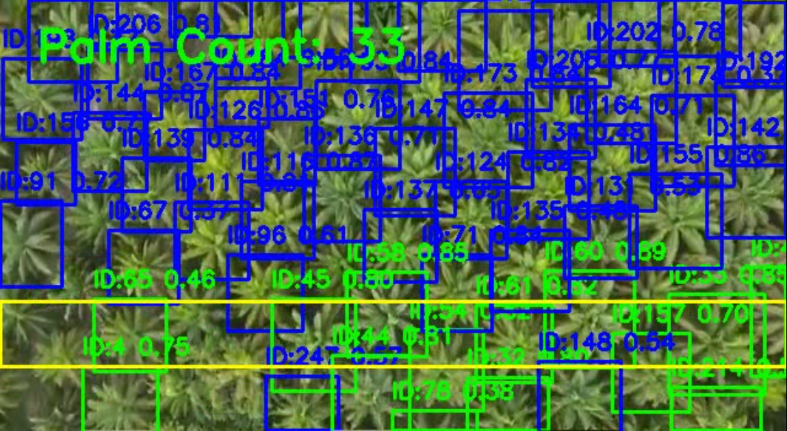

Fig. 9. Bot-Sort Tracking Output

Appendix B

Dataset and Annotation Samples

This appendix provides a brief overview of the dataset used for training and evaluation.

1. *Dataset Example*

The dataset consists of aerial images containing Date Palm trees collected from public sources and drone imagery.

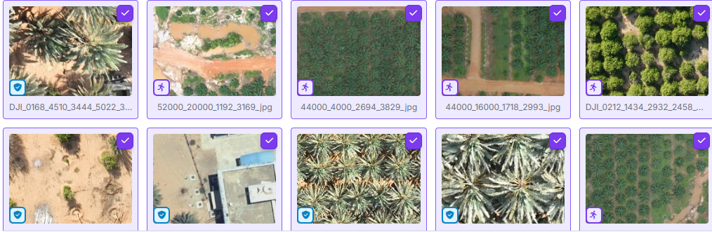

Fig. 10. Dataset Samples

1. *Annotation Format*

Annotations were prepared using the YOLO format, where each object is represented by normalized bounding box coordinates.

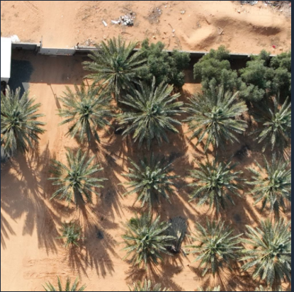

Fig. 11. Raw Data Image

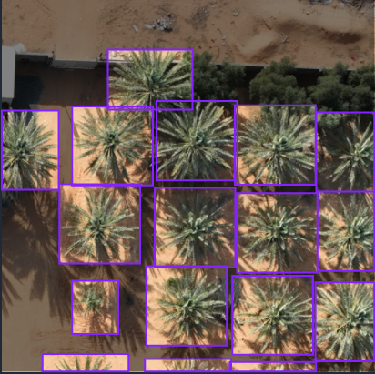

Fig. 12. Annotated Data Image

Appendix C

System Interface Snapshot

The system includes a simple frontend interface that allows users to upload images or videos and view detection results.

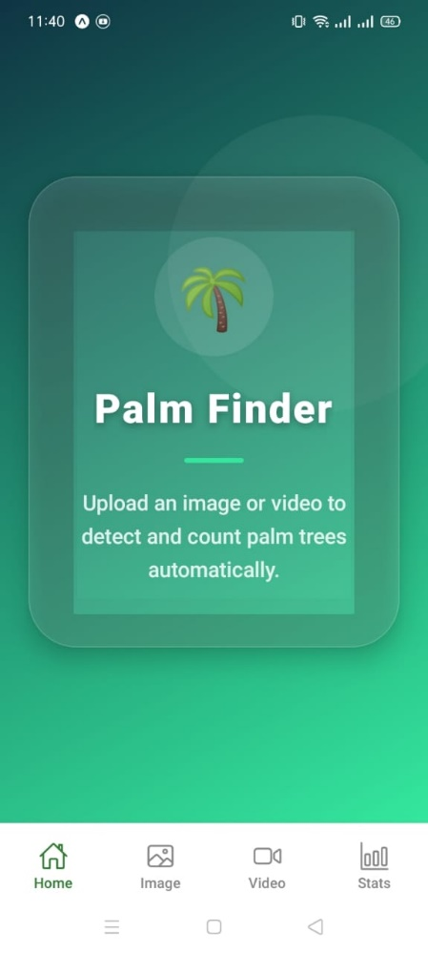

Fig. 13. Home Page Interface

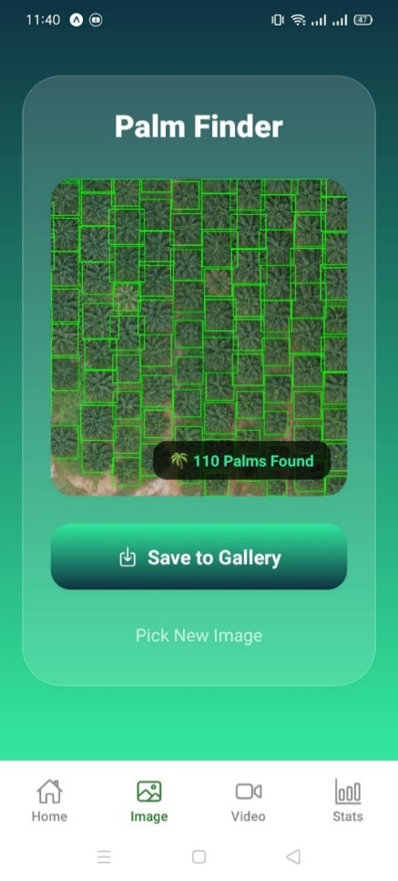

Fig. 14. Image Detection Interface